# TRACE CONCURRENT PROGRAM IN ORACLE EBS

1. Check box “Enable Trace”

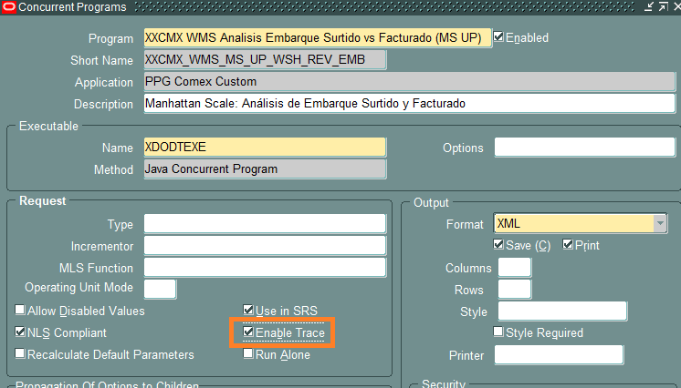

1. Set Profile “Concurrent: Allow Debugging” = YES

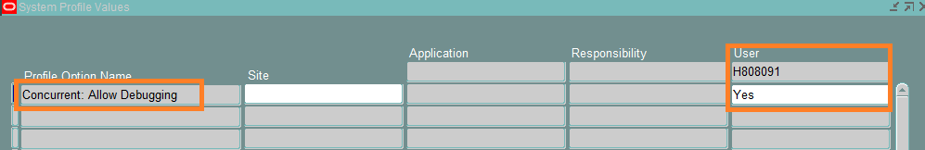

1. Just before run the Concurrent Programa, click “Debug Options” button

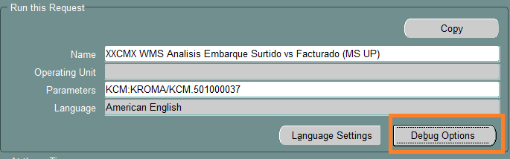

1. Check the boxes and choose a leve por each one.

1. Run the concurent
2. Run the follow sql sentences  
   select * from v$diag_info where name = 'Diag Trace';  
   select oracle_process_id from fnd_concurrent_requests where request_id = 255687768;
3. Find the trace file with name

*[oracle_process_id]*.trc

1. Format the trace file with tkprof  
   tkprof <trace file name> <name for output> sort=prsela exeela fchela